***Muiruri Vivian Wanjiru.***

***vimu***

**Project: Particle damping**

**Table of contents**

1. **Project background…………………………………………………………………………………………2**
   1. **Abstract………………………………………………………………………………………………2**
   2. **Introduction…………………………………………………………………………………………2**
   3. **Objectives……………………………………………………………………………………………3**
2. **Actual design………………………………………………………………………………………………….3**

**2.1 The Binder…………………………………………………………………………………..………5**

1. **Test measurements…………………………………………………………………………………………5**
   1. **Caruso………………………………………………………………………………………………..5**
   2. **Sand…………………………………………………………………………………………………..6**
   3. **Gravel………………………………………………………………………………………………...9**
   4. **Fine sand……………………………………………………………………………………………10**
   5. **Round Gravel………………………………………………………………………………………13**
   6. **Gravel with binder………………………………………………………………………………..15**
2. **Modal analysis……………………………………………………………………………………………….18**
3. **Conclusion……………………………………………………………………………………………………..29**
4. **Acknowledgment**
5. **Referemces…………………………………………………………………………………………………….30**

I joined Empa on the 1st of November 2022.

I first worked on a tapping machine which had a rebounce every time it was used. I soldered a 1k ohm potentiometer to the PCB which was to vary the resistance.

I then assembled a Festo linear axis to hold the lab's microphones during experiments.

**1.0 Project background.**

**1.1 Abstract**

Noise control has become a need in the recent past with industrialization and growth in different countries worldwide. This has led to many researchers trying to find solutions to reduce the impact of noise due to home modernization and improvements. Projects have been done where different ideas have been proven effective and some have not.

Various sound dampers have been realized and tested.

In particle damping, however, the right size of the particle to be used has been a discussion for a long time. This also breeds the question of which is the right-sized particle to use where and also why the selected particle works best for every need. The recent use of different materials to build structures for aesthetics has led to an even greater need to realize noise-damping materials to be used for each new design.

**1.2 Introduction**

Damping is the dissipation of vibratory energy in structures over time and distance. Noise damping is the process of reducing the impact of noise from the source to the receptors. There are different sound sources in buildings which are impact sound and airborne sound. Damping is done in consideration of the different materials used to build the houses and also the sound sources.

In recent studies, small-scale setup is built to predetermine the expected results on large scale with the same conditions applied.

In this report, I analyzed different particles between 0.1 to 6mm sizes in noise reduction. These particles are of different properties and also in structure. The gravel is filled on the whole wooden floor.

During my study, I realized that different characteristics affect the impact of damping in particles. These factors are;

* Density – packing density played a very big role in noise damping. The noise reduction level improved as I increased the level of the sand, doubling each time.
* Size – the size of the particles fairly determines how much is added and the impact in noise damping at large.
* Shape – this came into play when using the gravel. The rounded gravel proves to have better performance compared to the gravel which has slightly sharp edges.

Size and shape help in determining damping for the different particles whereas density relates to the mass.

The large-scale application of this experiment is in lightweight construction such as wood constructions, and the Blackhole experiment among others.

The highest level was 28cm, creating a gap to avoid exciting the particles once the hammer hit the top of the box.

**1.3 Objectives**

This experiment is done to test how particles behave at different filling heights in reducing noise levels on wood and compare the different particle's improvement on each level.

To also, test the behavior of the cavity resonance and the mode shapes at different frequencies.

To understand the mode shapes of the box at different frequencies when excited by a shaker and monitored by the Laser Doppler.

**2.0 Actual design**

A box of 1200*800*400 is used to hold the different particles and a tapping machine is placed on top of the box.

# A soft yellow-like elastomer at the bottom of the box acts as a (spring), it decouples the box from the ground. Four vibrometers are placed at the bottom of the box, randomly, to measure the vibrations of the box due to the tapping machine. Data is accessed from samurai software for sound and vibration analysis. With SINUS Acoustic Multichannel Universal Realtime Analysis Instrument, the FFT's of the four vibrators attached at the bottom can be analyzed in real-time. The data is in one third octave-bands

I tested the particles at different heights; **2**, **4**, 6, **8**, 10, **16**, and **28** cm. This was based on the 'mass law' which states, the higher the density of a material is, the more unlikely it vibrates when influenced by sound waves. Therefore, the spreading speed of sound waves passing through the material is weakened, and the insulation effect becomes better as the weight doubles incrementally. Doubling the mass resulted in a 6dB difference thus higher sound insulation. The effect of mass increase is seen with an increase in sound reduction and with the difference between the measured Lacc.

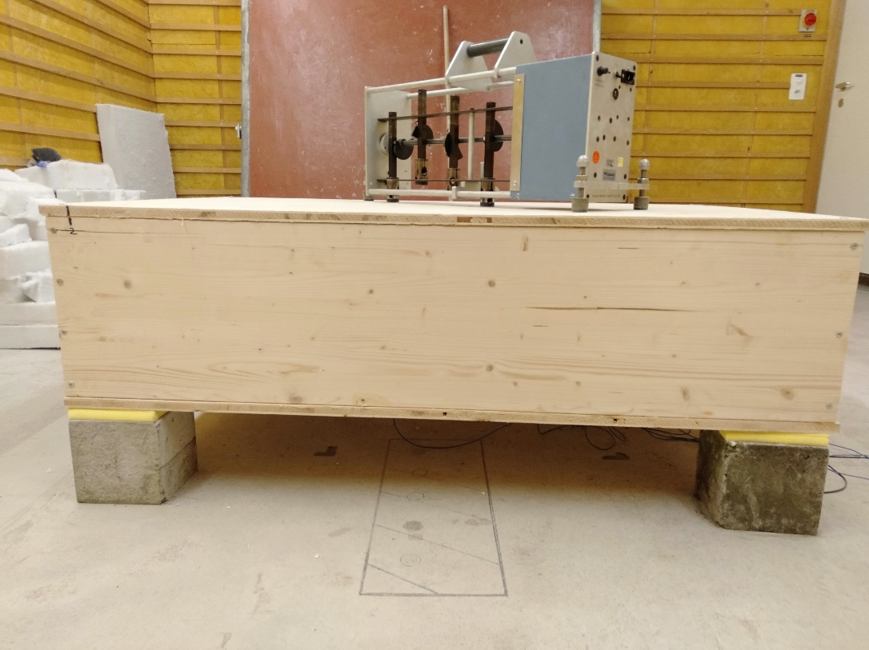

**Fig 1**. The measurement setup

All the measurements considered were below 5 kHz.

It is easier to understand the behavior of the box resonance below this frequency, despite a standing wave appearing which disappears shortly after at 100 Hz.

The following equations are used in the calculations of the measured sound impact;

**SPL(dB) = 10 log(p2 / po2)**

SPL is the sound pressure level.

p – is the mass at the different measured heights.

po– is the mass of the empty box.

In mass consideration;

**ΔLn = Lref – Lavg**

Where ; Lref is the mass at different measured heights.

Lavg is the mass of the empty box.

Lener is the square of the average of the Leq for the four channels.

**Lacc = 10 log ( Lener / (1*10^*-12))**

**2.1 The Binder**

I used the Brumma Boundsplitt 19. The binder improves noise protection, especially when used in timber construction.

The drying time for a layer of approximately 4cm was three days at the maximum. For the 4cm, I used 1kg of binder to add to the gravel, mixing for 7 to 10 minutes.

After drying the particles remain elastic.

**3.0 Test measurements**

**3.1 Caruso**

This is a kind of polyester fiber with good thermal and acoustic insulation properties. It has no chemical additives and is dust resistant.

I did a measurement using Caruso, to test the behavior of the cavity resonance before starting the experiment with any grain particle. However, even particles reduce cavity resonance during test.

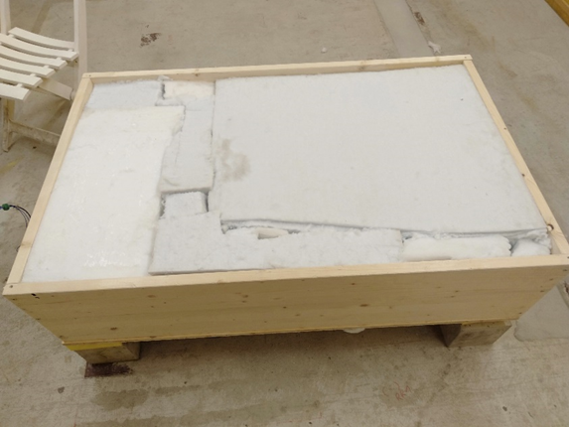

**Fig 2.** Box filled with Caruso.

I did a measurement to test the background noise with Caruso.

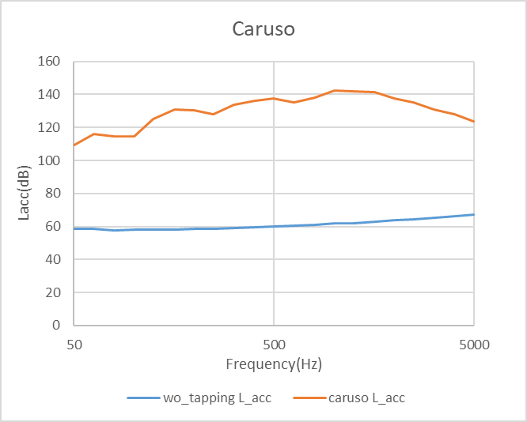

**Fig 3.** Background noise relation

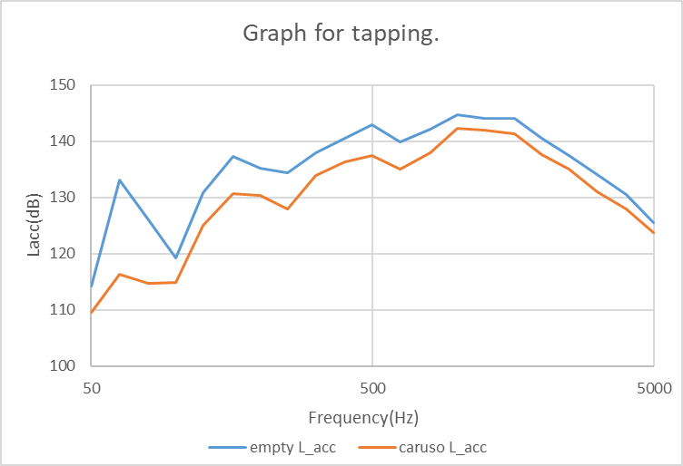

**Fig 4.** Results with tapping machine

The results in Fig 4 are with the tapping machine tapping the box empty and when filled with Caruso. The difference is approximately 10 dB in comparison.

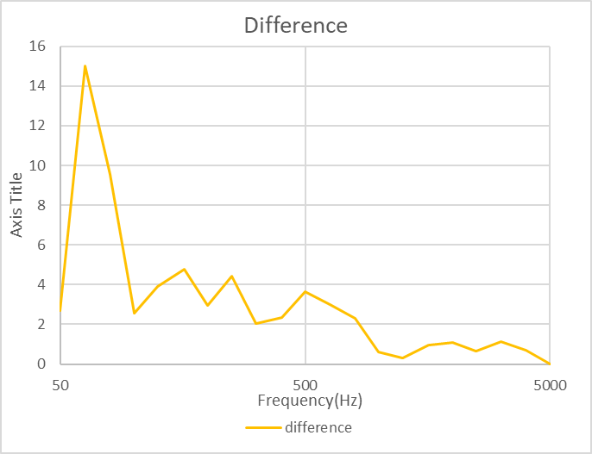

**Fig 5.** Difference for box empty and filled with caruso.

This difference is done in similar to the way the rest for this project is done. However, for Fig 5, the difference is between the two measurements done unlike the rest where it's between the measured height and the empty box.

An initial peak is seen (standing waves- two waves of the same frequency and amplitude are moving in opposite directions), which causes the interference thus the peaks.

**3.2 Sand**

These are sand particles of 1mm to 3mm in size, at different heights to test the damping effect.

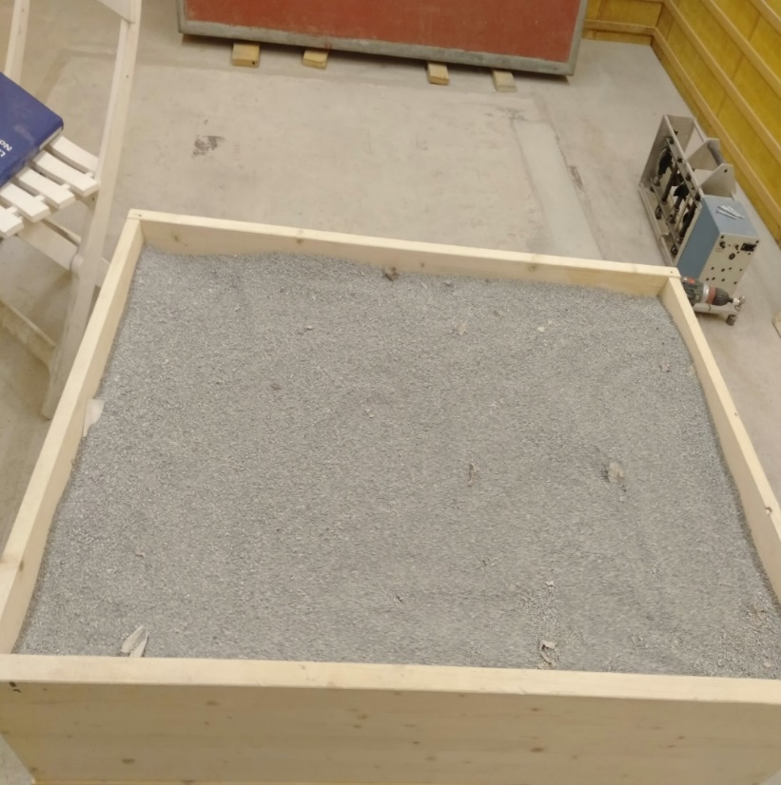

**Fig 5.** A representation of the type of sand measured.

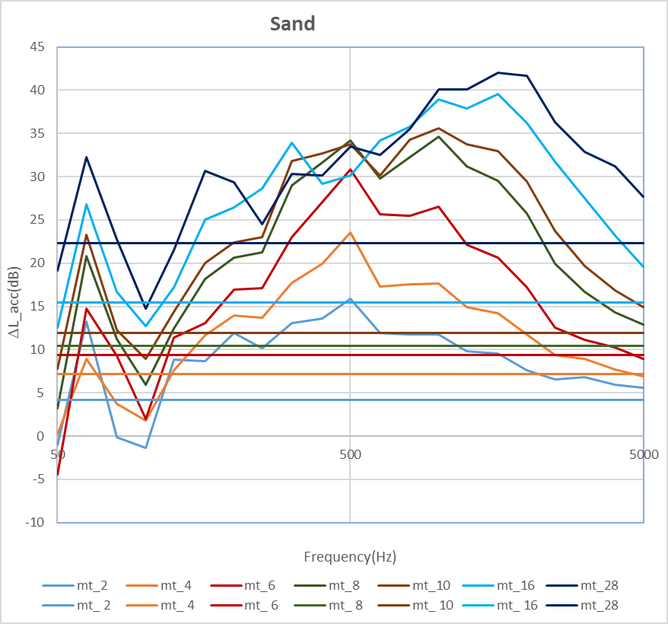

**Fig 6**. Lacc plot for sand.

Lacc is acquired from the FFT's acquired from the Samurai. This is plotted as the measured Lacc, as seen in Fig 6.

The mass is measured for the box with sand and in relation to the empty box, SPL is plotted as Lacc mass, in theoretical. These are the straight lines in Fig 6..

This is done for all the particles that follow.

The difference between Lacc measured and Lacc mass gives the difference for each level.

This difference is one for each height measured.

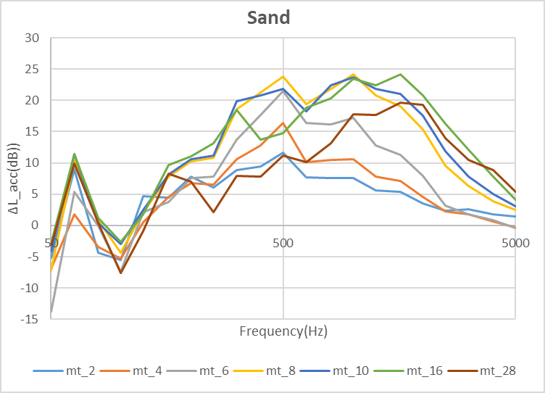

**Fig 7.** Difference plot for sand.  
Sand at 28cm is seen to have the best performance in sound reduction as compared to the other levels.

However, for layers of heights above 8cm, the damping effect is seen to be more pronounced.

**3.3 Gravel**

These are particles sized 3mm to 6mm at heights 2, 4, 6, 8, 10, 16, and 28cm as well.

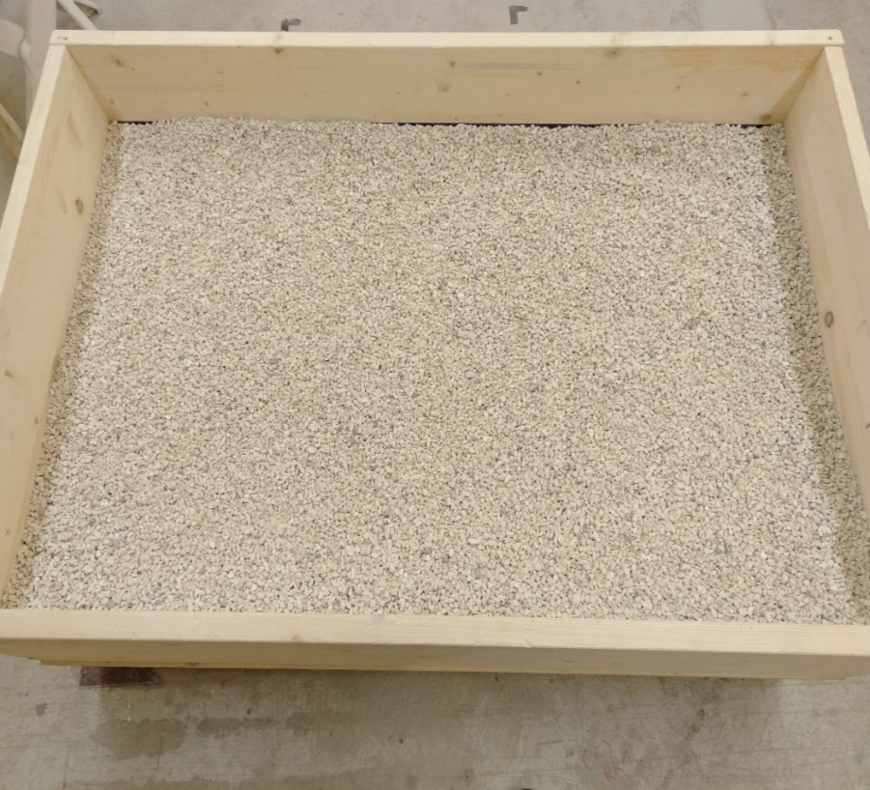

**Fig 8.** Gravel representation.

The results from the test done on gravel show to have better results than sand on frequencies above 500Hz and also to 5 kHz.

With gravel, we can see better improvements from 6cm to 28cm. An improvement is also seen with gravel at the 2cm mark as compared to the sand, gravel shows to have better damping properties than sand at the lower levels mark.

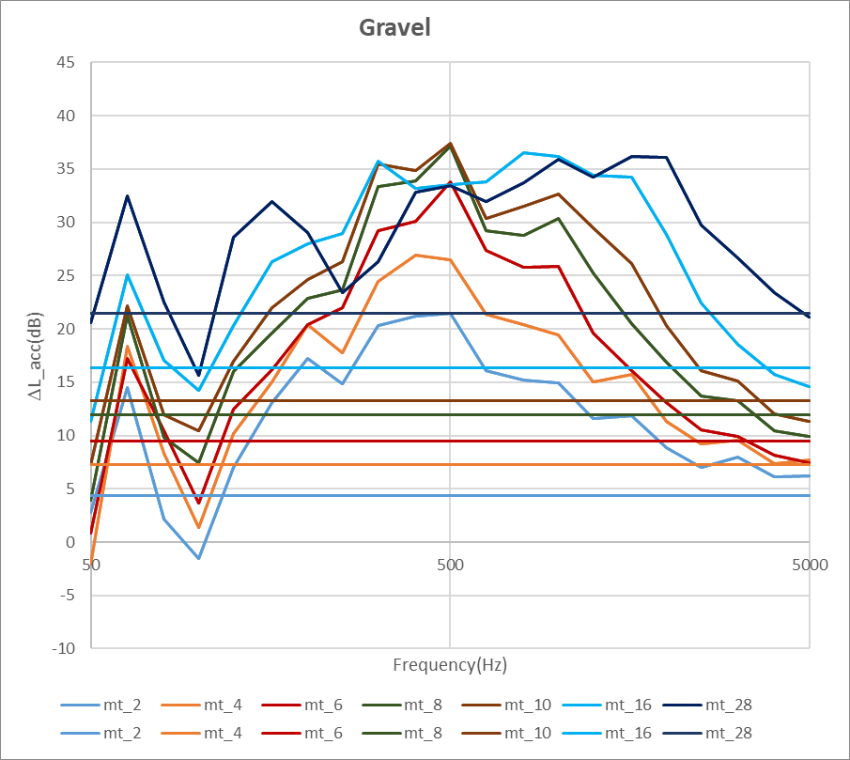

The difference relation between L_acc measured at different levels and in relation to mass is also done giving the results below;

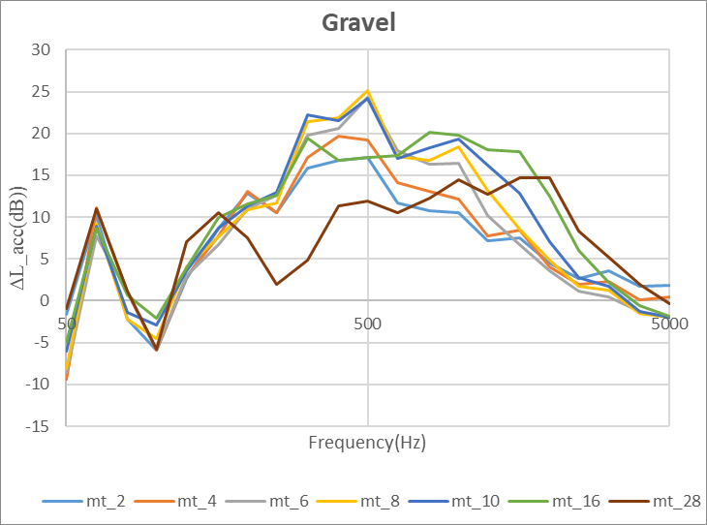

**3.4 Fine sand**

These are grain particles of approximately 1mm in size.

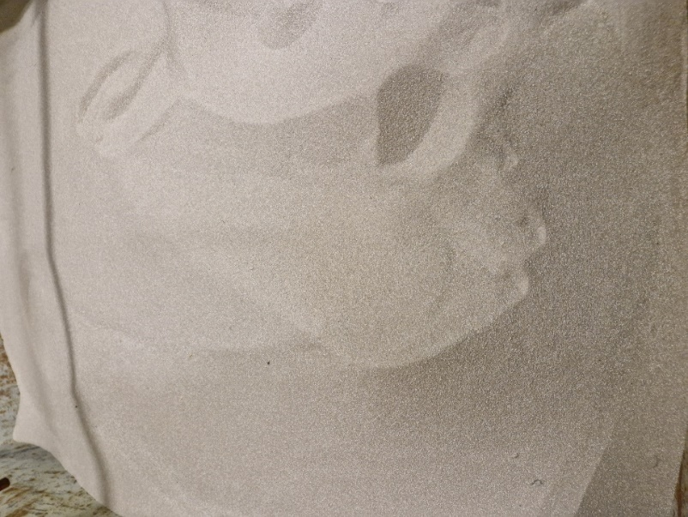

Measurements are done for the same levels and compared with the L_acc in relation to mass.

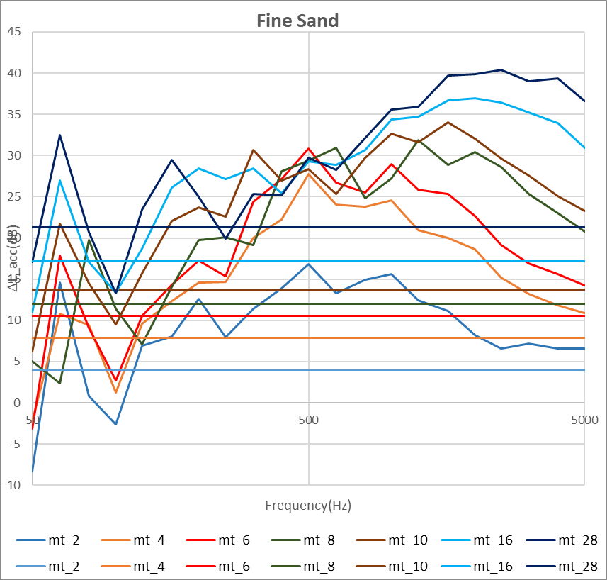

At lower frequencies, fine sand is seen to give better performance at frequencies between 100Hz to 500Hz, compared to the other particles. However, rounded gravel performs best at higher frequencies above 500Hz as the test results show.

A comparison is done with the difference being plotted;

The results of fine sand are comparatively seen to be in between those of sand and gravel when considering the difference of L_acc measured and the L_acc in relation to the mass.

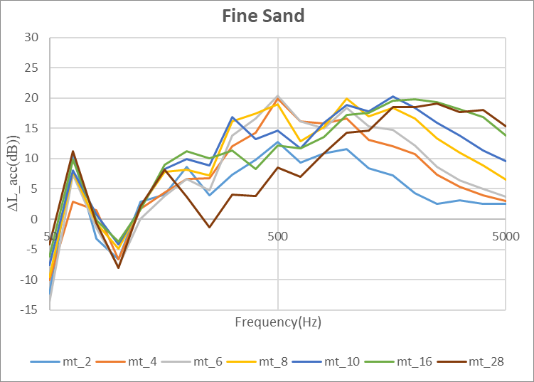

**3.5 Round gravel**

These particles are 4mm-6mm in size. The particle's behavior is similar to that of the gravel with improved performance, especially at higher frequencies.

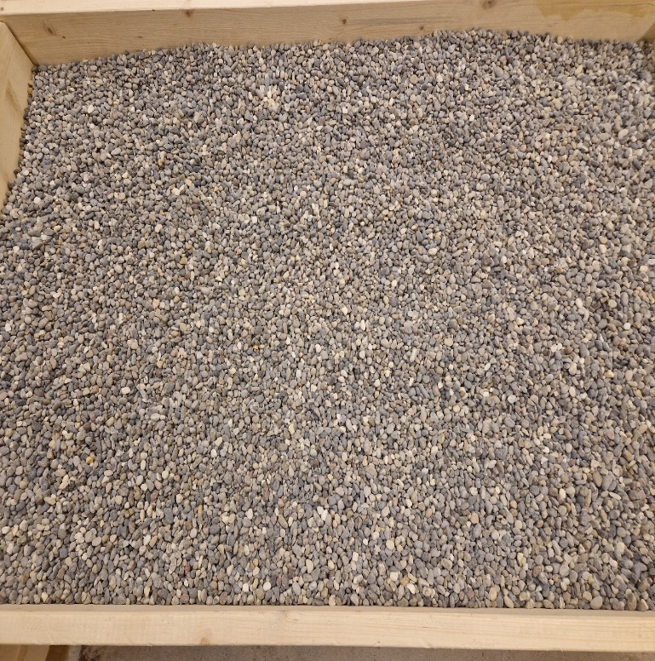

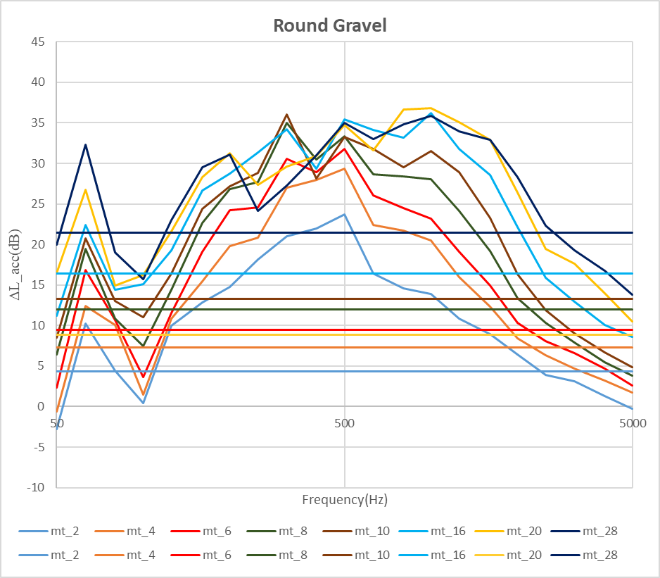

When comparing the difference of L_acc measured and the L_acc in relation to the mass, the 28cm is seen to be better than the other levels by a big gap in between.

A new curve appears for the level between 16cm and 28cm. This test is done to try and fill the gap that appears between 16cm and 28cm. However, with repeated measurement, it appears to be completely above all the other levels.

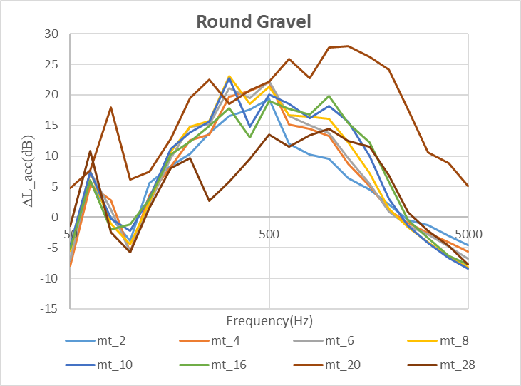

In comparison, the rounded gravel is seen to have improved performance than all the other particles on average.

**3.6 Gravel with binder**

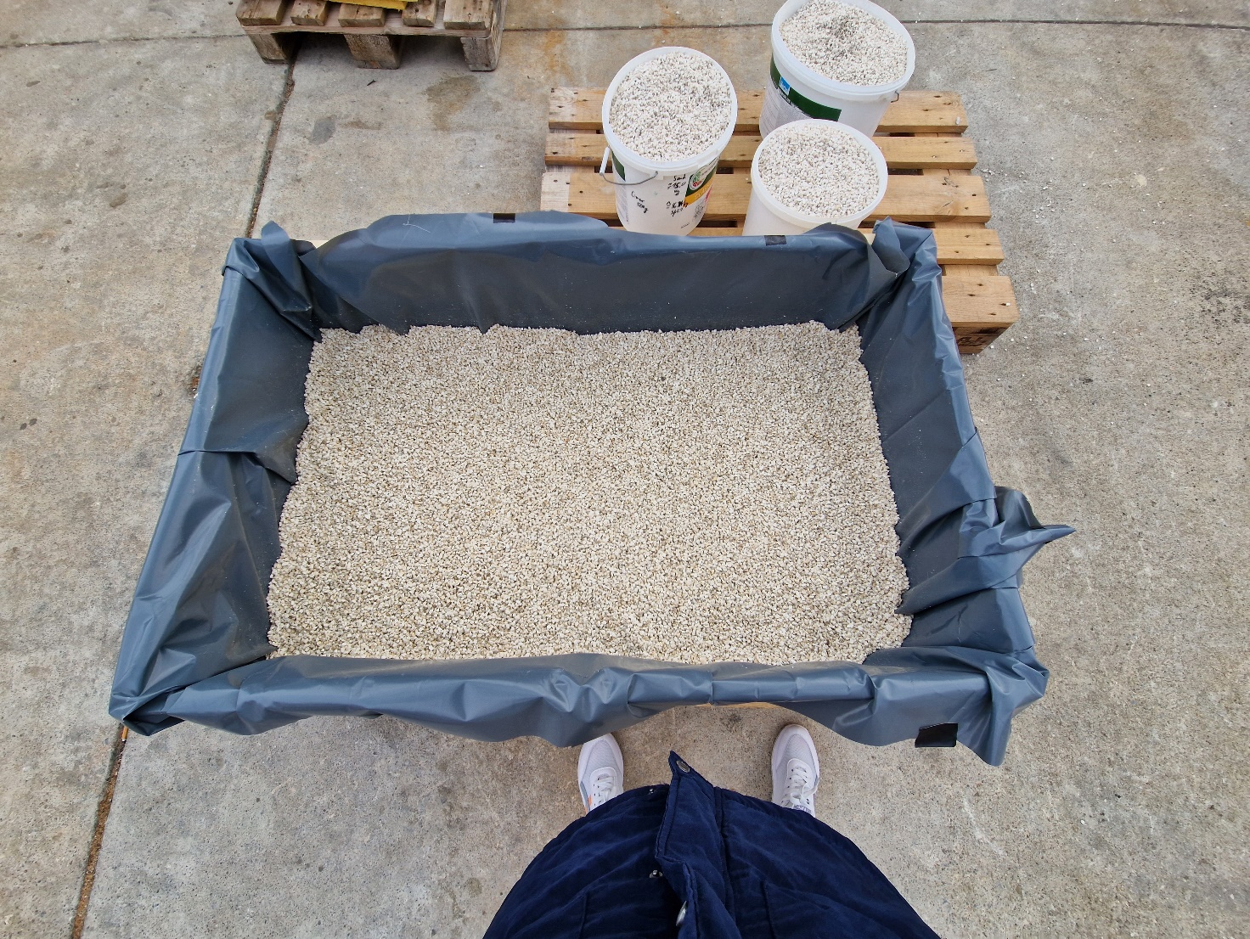

For this test, a binder glue is used to stick the particles together to reduce the vibrations of the particles.

The test is repeated with 4, 8, 12, 16, and 32 cm levels with the same boundary conditions still holding.

The results are done in comparison with the empty box to get the measurements for L_ACC for the difference.

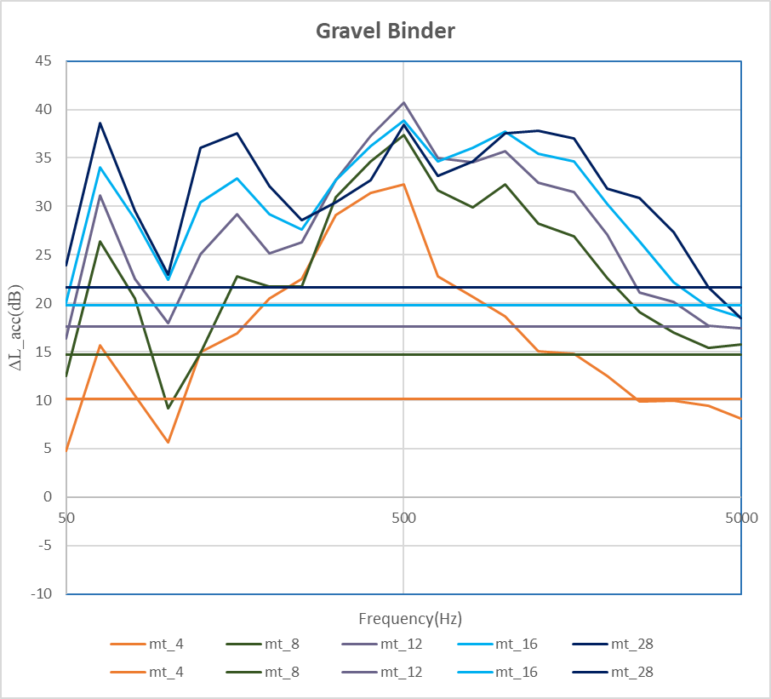

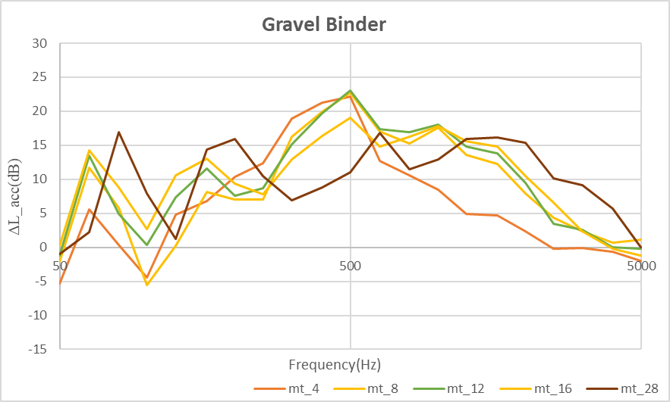

A slight difference is seen when the gravel is mixed with the binder as compared to the results with gravel without binder.

A comparison of the difference is done below;

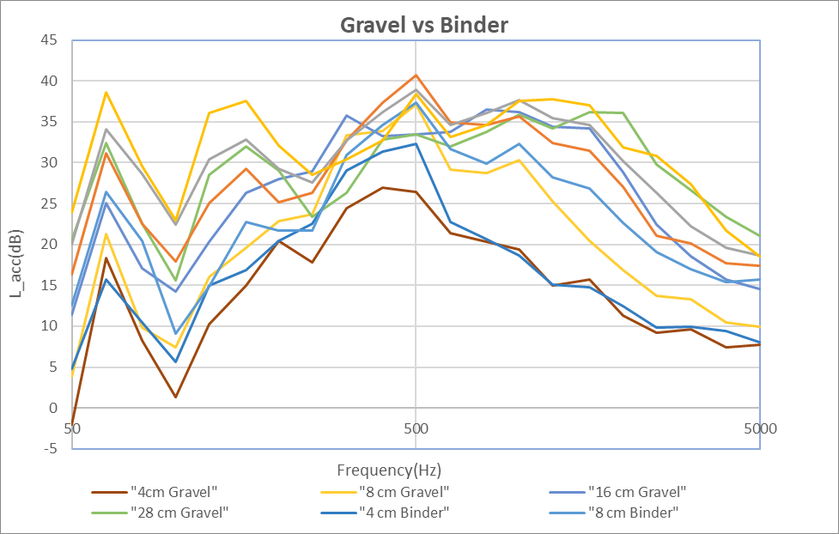

And when the difference is compared;

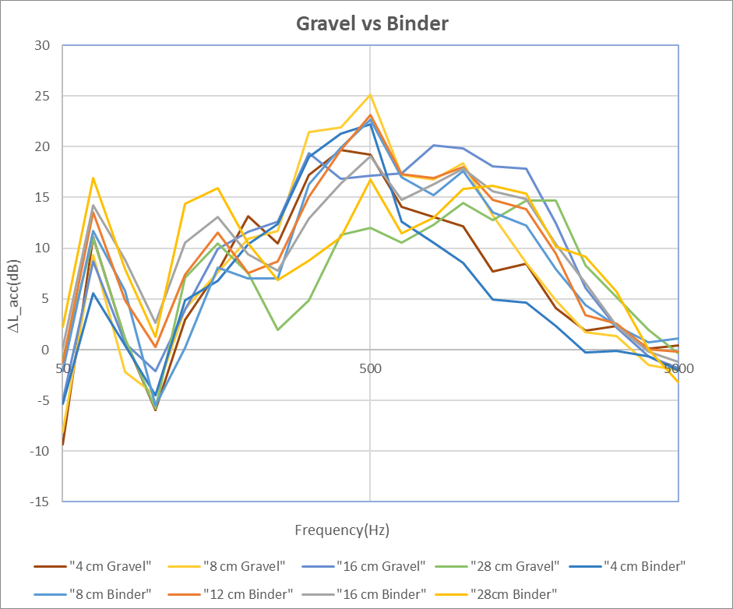

**4.0 Modal Analysis**

Measurement is done for the small set up which is the wooden box filled with particles at different levels. The results from this box are to be compared with the big full particle-covered floor in the lightweight facility done during measurements.

In relation, it is easier to do the test from the small prototype before filling the floor for measurement.

I experimented with the Laser Doppler to determine the mode shapes of the box with and without Caruso first at frequencies between 20Hz and 3.2 kHz to test the behavior of the cavity when excited by a shaker.

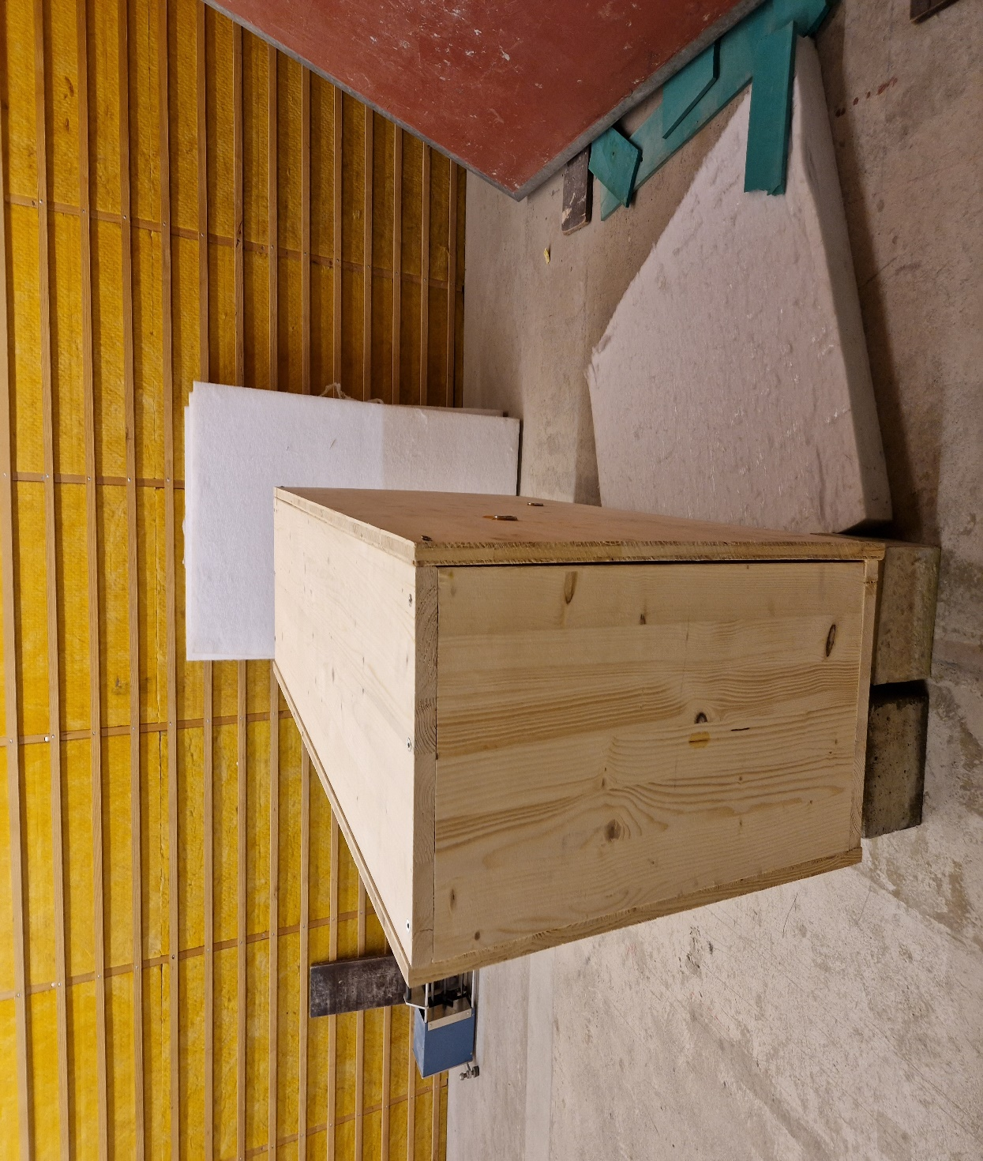

The box is oriented in a manner as shown above with the shaker on the right outside the box and laser Doppler measuring the opposite left side.

There are two channels used as the reference, channel 1(force) and channel 2(acceleration)

An average of all the points is done and results are plotted on frequencies between 20Hz to 3200 kHz. The other graph shows results between 20Hz and 500Hz.

Initially, a test is carried out with the box filled with Caruso and the box empty, with the laser Doppler monitoring the top of the box.

The code below is used to get the average FRF's of all the point values of the frequencies.

%% here enter the data for the import

%add here filepath of .mat-file

file_path = 'G:\staff\vimu\matlab\test 1\ref 2';

%add here the names of the .mat-files

filename1 = 'test w caruso.mat';

filename2 = 'test wo caruso.mat';

%Add here the number of measurement points

p_numb = 135;

%Add here Reference Channel

ref_ch = 2;

%upper frequency limit

f_up = 500;

%% all data entered now only, start import

% Import first file

file1 = fullfile(file_path, filename1);

data_struct1 = open(file1);

freq1 = data_struct1.FRF.x;

FRF1 = nan(length(freq1), p_numb);

for s = 1 : p_numb

FRF1(:,s) = eval(['data_struct1.FRF.Point_' num2str(s) '.Ref_In_' num2str(ref_ch)]);

end

FRF_mean1 = mean(abs(FRF1), 2);

freq_limited1 = freq1(1:find(freq1<=f_up,1, 'last'));

FRF_mean_limited1 = FRF_mean1(1 : length(freq_limited1));

% Import second file

file2 = fullfile(file_path, filename2);

data_struct2 = open(file2);

freq2 = data_struct2.FRF.x;

FRF2 = nan(length(freq2), p_numb);

for s = 1 : p_numb

FRF2(:,s) = eval(['data_struct2.FRF.Point_' num2str(s) '.Ref_In_' num2str(ref_ch)]);

end

FRF_mean2 = mean(abs(FRF2), 2);

freq_limited2 = freq2(1:find(freq2<=f_up,1, 'last'));

FRF_mean_limited2 = FRF_mean2(1 : length(freq_limited2));

%% plot data

freq_3rd = [25 31.5 40 50 63 80 100 125 160 200 250 315 400 500 630 800 1000 1250 1600 2000 2500 3150 4000 5000 6300 8000 10000 12500 16000 20000];

freq_oct = {' ' '31.5' ' ' ' ' '63' ' ' ' ' '125' ' ' ' ' '250' ' ' ' ' '500' ' ' ' ' '1k' ' ' ' ' '2k' ' ' ' ' '4k' ' ' ' ' '8k' ' ' ' ' '16k' ' '};

figure(1) %make figure

loglog(freq1, FRF_mean1) %plot data from file1

loglog(freq1, FRF_mean1, 'r') %keep the graph

hold on

loglog(freq2, FRF_mean2) %plot data from file2

loglog(freq2, FRF_mean2, 'b') %keep the graph

xlim([20 3200]); %set limit of x-axis

set(gca, 'XTick', freq_3rd); %set positions of x_ticks

set(gca, 'XTickLabel', freq_oct); %put xtick labels of x_ticks

xlabel('Frequency [Hz]'); %name x-axis

ylabel('FRF - Magnitude [N/m/s]'); %name y-axis

figure(2) %make figure

loglog(freq_limited1, FRF_mean_limited1) %plot data

loglog(freq_limited1, FRF_mean_limited1, 'r') %keep the graph

hold on

loglog(freq_limited2, FRF_mean_limited2) %plot data

loglog(freq_limited2, FRF_mean_limited2, 'b') %keep the graph

xlim([20 3200]); %set limit of x-axis

set(gca, 'XTick', freq_3rd); %set positions of x_ticks

set(gca, 'XTickLabel', freq_oct); %put xtick labels of x_ticks

xlabel('Frequency [Hz]'); %name x-axis

ylabel('FRF - Magnitude [N/m/s]'); %name y-axis

For the results from Optomet, the Frequency Response Functions generated by channel one(force), are used in Matlab for modal analysis. For the Matlab script, the Line fitting method is used in step two for the stability diagram to determine the fit between the generated FRF and the measured FRF. These results in a Bode curve plot as shown below. The frequency range considered is 130Hz to 150Hz.



Graph results when reference two (because channel one had some noise effect seen in the coherence spectrum from the optomet scan) is considered;





These results are compared to using a tapping machine to excite the box, measuring using vibrometers, and using a shaker with a laser doppler.

The box is filled with Caruso and compared with the box being empty. Below is a graph showing results using the tapping machine;

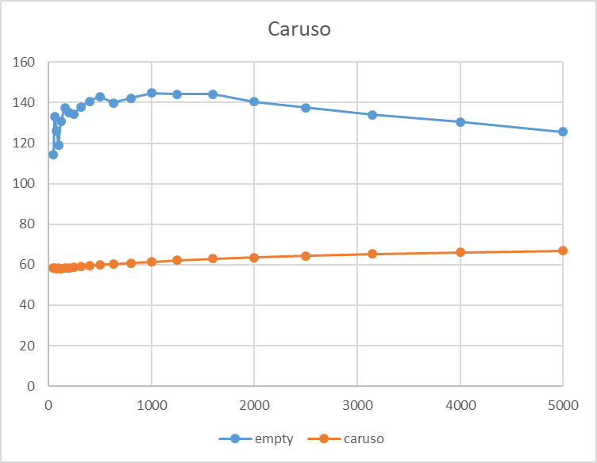

However, after comparison, these results are not based on the same boundary conditions as to using the tapping machine. When using the laser vibrometer, the box is measured in a vertical position as compared to when using a tapping machine on top of the box in which the box is used in a horizontal position.

In correlation, the shaker acts as the force, the box is the mass, and the yellow elastomer acts as the spring. Previously using the sand and Caruso acted as the damper.

I experimented with the box on the concrete supports which decouple the box from the ground and also on the yellow elastomer to act as spring and box and the mass.

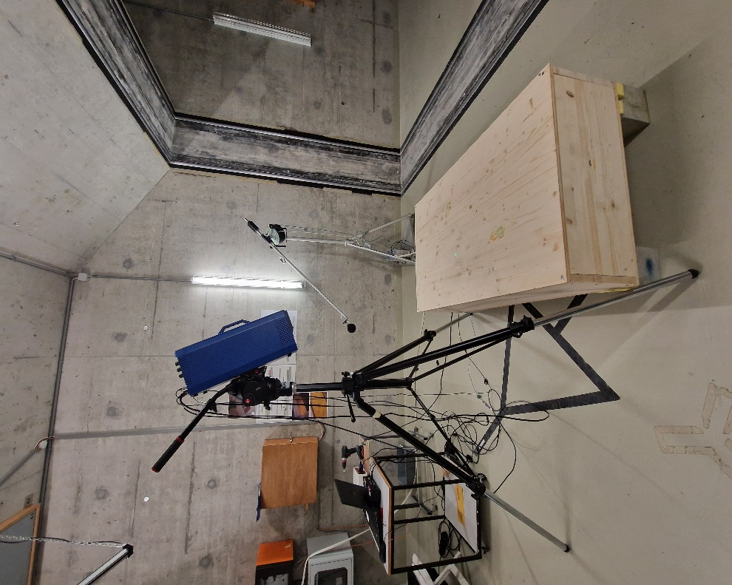

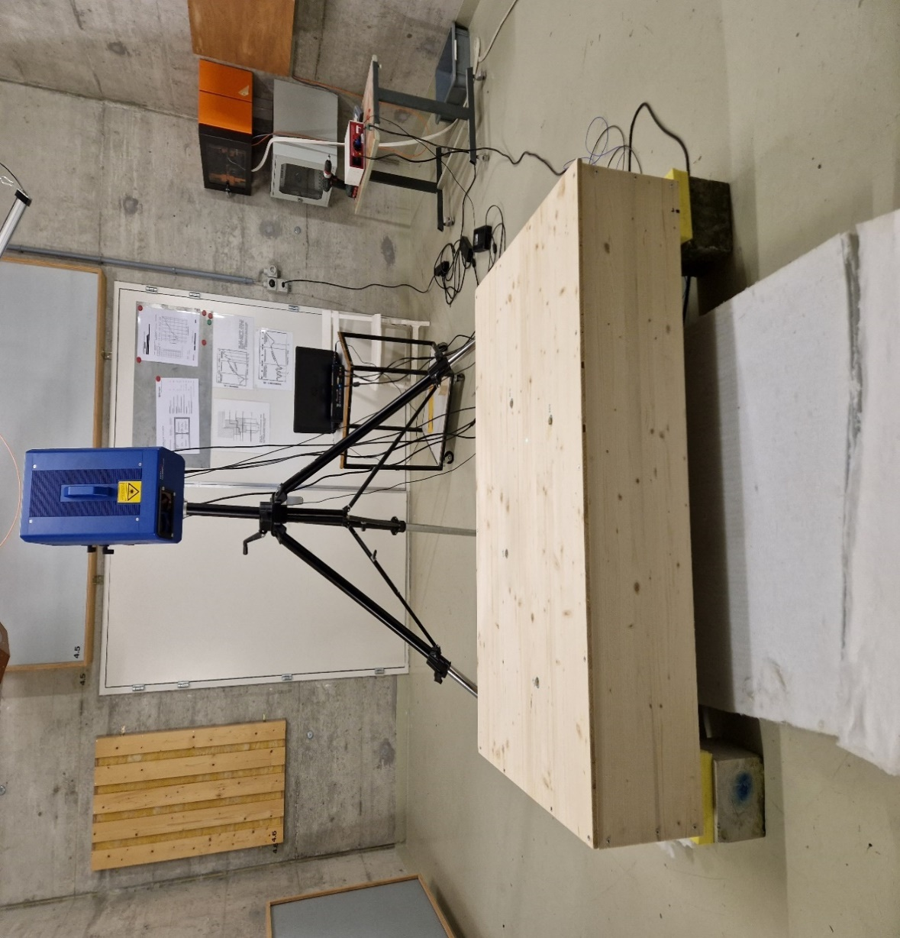To understand the different mode shapes that occur to the box, I did further experiment for the top box, the bottom side, and also the box without the top, which are the different orientations.

For this experiment, reference channel 1(force) is considered.

The results are analyzed based on the average of the FRF values of frequencies ranging between 20Hz and 3200Hz.

The Least Square Complex Exponential method works to identify the mode shapes that occur between the defined frequency range. From the stability diagram it is possible to identify the probable modes from the peaks and also from the Optomet scan spectrum.

Bottom are the results of having the laser vibrometer measure the bottom of the box with the shaker on the inside at the bottom, in this case, the top of the box is still in place and the box is inverted.

The top represents the results of the laser vibrometer measuring the top of the box with the shaker at the bottom of the box.

With open, the shaker is attached at the bottom of the box, the top of the box is removed and the box is inverted.

The elastomer supports and the decoupling from the ground supports remain to hold the boundary conditions as they were previously when using the tapping machine.





On analysis of the data, different mode shapes were seen to appear at different frequencies. The results from the open top are presumed to be similar to those of the bottom side measurements which is seen from the results. However, a different kind of mode shape appears at the 60-80 Hz frequency. The edges of the box are seen to be freely moving.

Wooden supports are attached at the edges to test the box behavior if the sides are supported.

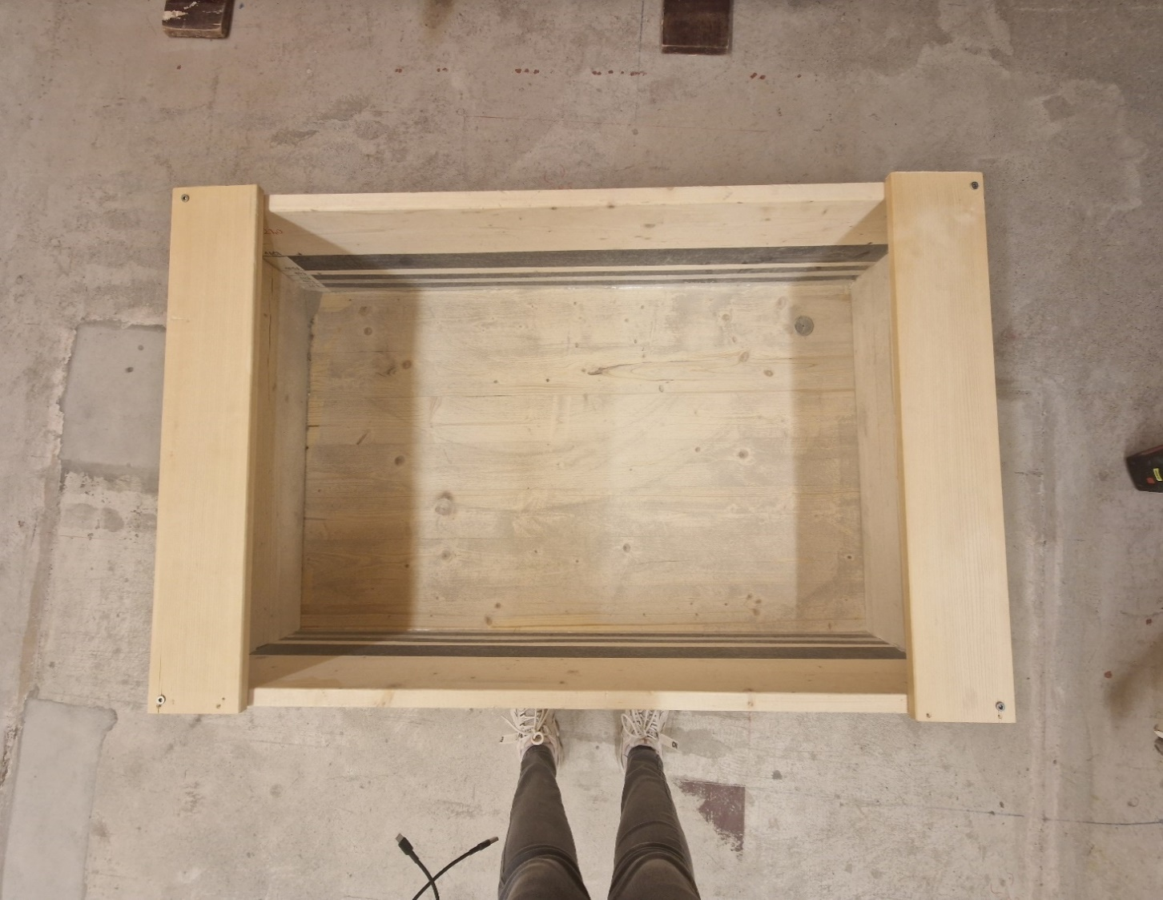

The measurements are done at 0.3 amplitude and compared to the previous measurements.

The graphs below indicate the results from 20Hz to 3.2kHz and 20Hz to 500Hz respectively.





The results of the bottom box are in relation to the measurements I did with the Caruso and the sand using the tapping machine.

I analyzed the bottom box results to determine the number of mode shapes that occur between certain frequency ranges.

These frequency ranges are determined using the center frequencies of the 3rd Octave bands (Fc) which give the upper frequency (Fu) and the lower frequency (Fl).

With the coordinates, the frequency range, and FRF for all the 244 points from Optomet, I can run a Matlab script that determines the mode shapes that occur between Fl and Fu, for 0 to 1000Hz.

With Modal Analysis Criteria, I determined the quality of the modes for the frequencies Fu and Fl.

|  |  |  |
| --- | --- | --- |
| **Fl(Hz)** | **Fu(Hz)** | **sum of modes** |
| 0 | 20 | 6 |
| 20 | 50 | 1 |
| 50 | 70 | 1 |
| 70 | 100 | 1 |
| 100 | 150 | 2 |
| 150 | 160 | 1 |
| 160 | 170 | 1 |
| 170 | 180 | 1 |
| 180 | 195 | 2 |
| 195 | 220 | 1 |
| 220 | 250 | 1 |
| 250 | 300 | 1 |
| 300 | 350 | 2 |
| 350 | 400 | 3 |
| 400 | 450 | 3 |
| 450 | 500 | 3 |
| 500 | 550 | 4 |
| 550 | 600 | 2 |
| 600 | 650 | 3 |
| 650 | 700 | 3 |
| 700 | 750 | 3 |
| 750 | 800 | 3 |
| 800 | 850 | 3 |
| 850 | 900 | 4 |
| 900 | 950 | 3 |
| 950 | 1000 | 4 |

**Conclusion**

The impact realized when gravel is used as a damper varies depending on the size and mass of the different particles used. This is seen when the different shapes of gravel are compared.

The binder has a slight difference when used on gravel. When used in lower-level mass, the particles are presumed to stick together thus reducing the vibration of the particles when excited.

**Acknowledgment**

I would like to express my sincere gratitude to my supervisor, Schoenwald Stefan for his constant guidance and support with valuable feedback throughout the project. Utmost respect for his deep knowledge and expertise in the field of engineering and for his diligence in research.

A warm thanks also to Vallely Sven and Wusterhausen Mandy for the assistance and provision of necessary resources contributing to the completion of this project.

**References**